Class Supplies List- 9th Grade | List also available on our website: www.afamistadhs.org

All lower school scholars need the following items for EVERY class:
- Pens (blue/black and red)
- Pencils and erasers
- Loose-leaf notebook paper (college-ruled, 3-hole punched)
- Standard-sized post-it notes
- Highlighters (at least 1 set of multicolored)
Items may be purchased at Walmart, Target, etc.
Scholars will need the following supplies for 9th grade classes:
Literature I | Pre- AP World History | Physical Education
One 1” binder or two pocket folder | One 1” binder  One composition notebook (not quadrille) | Drawstring or Plastic Bag
Pre-AP Seminar I | Foundations of Leadership
One 1” binder | One 2-pocket folder  One composition notebook
Algebra I | Physics
One 1” binder  Composition-bound quadrille (graph-paper) notebook  TI 83,TI 84, TI 84 plus CE or TI 89 calculator with trigonometric functions (sine, cosine, and tangent) | Quadrille Notebook  One 1” binder  TI 83 or 84 calculator (same calculator used for math)

Picture references for math/science supplies:
Quadrille notebook | Composition notebook | 2-pocket folder | TI-83, TI-84, TI-84 plus CE, TI- 89 Calculator
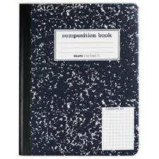Outside Inside  (Please make sure the gridlines are light, not dark.) | 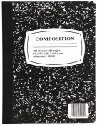 | 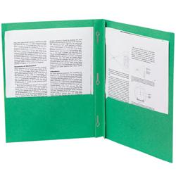 | 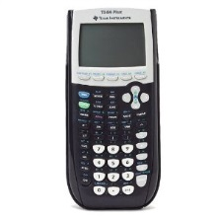  TI calculators purchased for use in Algebra classes meet the calculator requirement for all math classes at AHS. TI- 84 plus CE is the recommended type. May be purchased at Walmart, Target, Amazon etc.

