Class Supplies List – 10th Grade | List also available on our website: www.afamistadhs.org
All lower school scholars need the following items for EVERY class:
- Pens (blue/black and red)
- Pencils and erasers
- Loose-leaf notebook paper (college-ruled, 3-hole punched)
- Standard-sized post-it notes
- Highlighters (at least 1 set of multicolored)
Scholars will need the following supplies for 10th grade classes:
Literature II | World History (AP and non-AP)
Binder with at least three tabbed dividers  Notebook (spiral or composition-bound)  Yellow standard-size post-it notes | Binder with at least three tabbed dividers  Notebook (spiral or composition-bound)  2-pocket folder  Lined index cards
Pre-AP Seminar II | Foundations of Leadership II
Notebook (spiral or composition-bound)  Binder with dividers | Binder with at least three tabbed dividers  2-pocket folder  Lined index cards
Geometry | Chemistry
2-pocket folder  Composition-bound quadrille (graph-paper) notebook  Ruler (at least 6 inches long, must measure in inches and centimeters)  Compass and protractor  TI 83,TI 84, TI 84 plus CE or TI 89 calculator with trigonometric functions (sine, cosine, and tangent) | Binder with at least three tabbed dividers  2-pocket folder  Spiral bound notebook with removable pages  Calculator (may be the same calculator used for math)

Picture references for math/science supplies:
Quadrille notebook | Compass | Protractor | TI-83, TI-84, TI-84 plus CE, TI- 89 Calc.
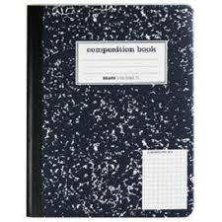Outside Inside  (Please make sure the gridlines are light, not dark.) |  | 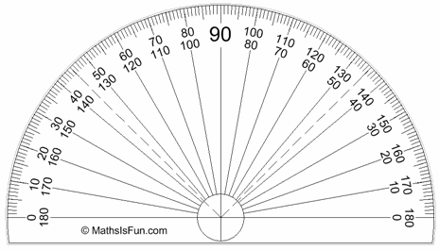 | 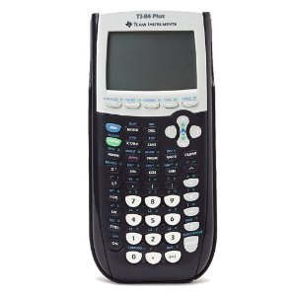  TI calculators purchased for use in Geometry classes meet the calculator requirement for all math classes at AHS. TI- 84 plus CE is the recommended type. May be purchased at Walmart, Target, Amazon etc.

